CSCI 2215 Final Project

Create a menu for the user.

The menu should have four options:  
1) Print Triangle with User Input, Should be Inherited From a New Class’s Function  
2) Read Quarterly Expenses From File and Print to a New File in a Table Format  
3) Check to see if an Entered Product ID is found from a store’s DataBase via C-Strings  
4) Quit

The menu should continue to populate until the user chooses to quit.

Guidance:

1. In our new class called “TriangleClass”, we should create a function that accepts an integer from the user in order to create a triangle.
   1. We should use input validation that doesn’t allow the user to input anything other than an odd number.
   2. The user will input the BASE of the triangle, the function will then calculate the HEIGHT.   
      HEIGHT = ceil(BASE / 2);
   3. You will need certain variables in order to do this:
      1. the BASE of the triangle
      2. the HEIGHT of the triangle
      3. the MIDDLE, LOWER, and UPPER bound of the array (middle = BASE /2;)
      4. an array of characters that is dynamically allocated memory   
         (char *stars = new char[BASE];)
   4. Create a for-loop that assigns stars to elements in the array, starting from the middle point, and moving outwards after each iteration (or row)

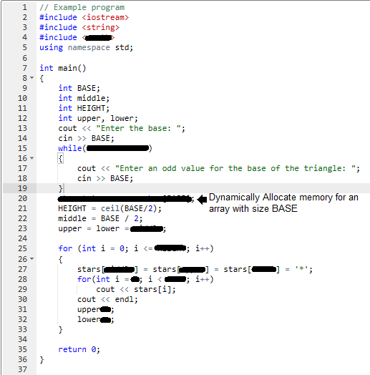

This example is not a class of its own. This is meant to show you the function.

1. 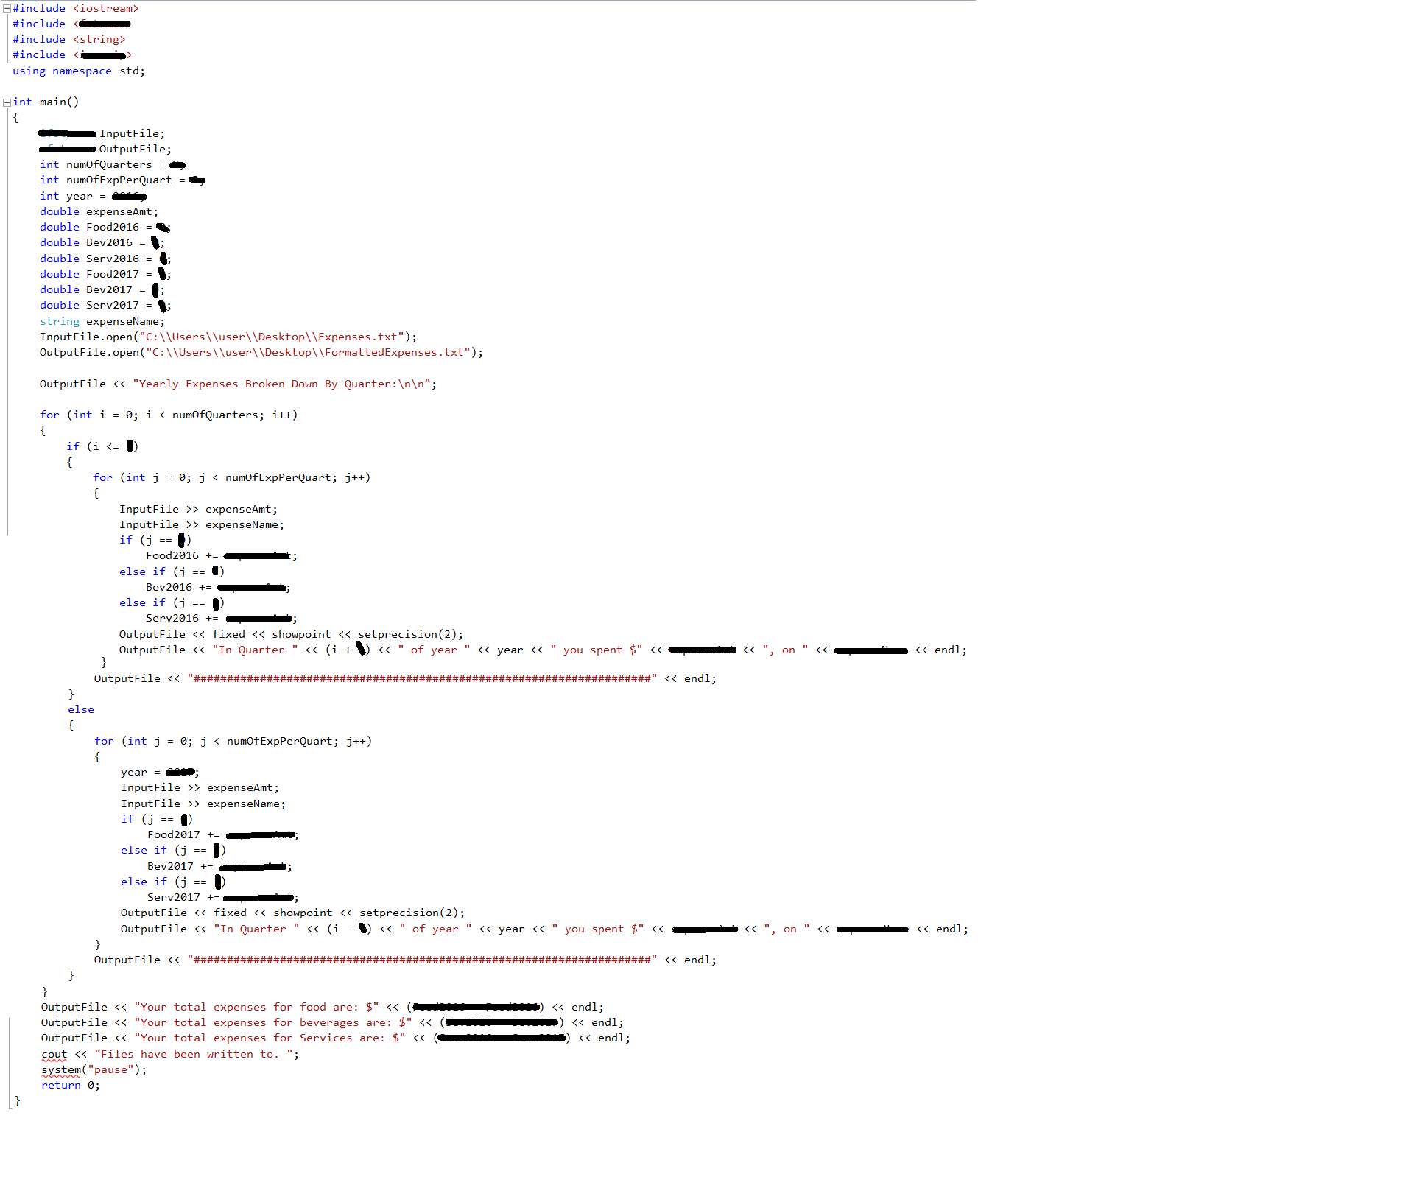The attached file contains a list of expenses and what they were for. The program will capture data from FY2016 Q1 to FY2017 Q4. You will print the data back into the Output File in a more presentable fashion. You will also sum up the expenses, based off of their name, and print the totals at the bottom of the file.

The formatted text in the Output File will look like the following: 

**Yearly Expenses Broken Down By Quarter:**

**In Quarter 1 of year 2016 you spent $55236.20, on Food**

**In Quarter 1 of year 2016 you spent $6521.00, on Beverages**

**In Quarter 1 of year 2016 you spent $2265.99, on Services**

**#####################################################################**

**In Quarter 2 of year 2016 you spent $7854.20, on Food**

**In Quarter 2 of year 2016 you spent $65256.00, on Beverages**

**In Quarter 2 of year 2016 you spent $2875.99, on Services**

**#####################################################################**

**In Quarter 3 of year 2016 you spent $55236.20, on Food**

**In Quarter 3 of year 2016 you spent $65452451.00, on Beverages**

**In Quarter 3 of year 2016 you spent $2745265.99, on Services**

**#####################################################################**

**In Quarter 4 of year 2016 you spent $59855236.20, on Food**

**In Quarter 4 of year 2016 you spent $65123.00, on Beverages**

**In Quarter 4 of year 2016 you spent $265.99, on Services**

**#####################################################################**

**In Quarter 1 of year 2017 you spent $236.20, on Food**

**In Quarter 1 of year 2017 you spent $21.00, on Beverages**

**In Quarter 1 of year 2017 you spent $65.99, on Services**

**#####################################################################**

**In Quarter 2 of year 2017 you spent $556.20, on Food**

**In Quarter 2 of year 2017 you spent $65.00, on Beverages**

**In Quarter 2 of year 2017 you spent $22.99, on Services**

**#####################################################################**

**In Quarter 3 of year 2017 you spent $536.20, on Food**

**In Quarter 3 of year 2017 you spent $61.00, on Beverages**

**In Quarter 3 of year 2017 you spent $25.99, on Services**

**#####################################################################**

**In Quarter 4 of year 2017 you spent $5436.20, on Food**

**In Quarter 4 of year 2017 you spent $421.00, on Beverages**

**In Quarter 4 of year 2017 you spent $465.99, on Services**

**#####################################################################**

**Your total expenses for food are: $119947125.60**

**Your total expenses for beverages are: $65589919.00**

**Your total expenses for Services are: $2751254.92**

1. If the user chooses “3” we will have them enter a keyword to search for through a company’s database of items.
   1. We will need an array for product ID/names, as well as an array for correlating product prices
   2. We should allow the user to search for substrings and/or keywords
   3. If the user does not find anything, ask if they would like to search again.  
      If the user finds what he/she is looking for, display the product name, price, and ask how many the customer would like to buy.
   4. Compute the total cost of the items to be purchased and display to the user.
   5. **Follow along in Chapter 10 for a great example to work with**